Pathways programmes in New Zealand Schools

Sabbatical Report

Richard Campbell

Principal Paraparaumu College

Term 3 2012

- Context
- Paraparaumu College
- Wellington Region Polytechnics
- Wellington Schools
- Wairarapa Schools
- Manawatu School
- North Shore Schools
- South Auckland Schools
- Waikato Schools
- Bay of Plenty Schools
- South Australia
- Summary Observations - Pathways
- Thoughts and suggestions

- Context
In recent years increasing numbers of students have been staying longer at school. Many of these students are not aiming to head towards University but are requiring courses of study which can lead to further education and training either at a Polytechnic or in the workforce.
The Government has been driving the upskilling of the workforce and a range of resources and initiatives have evolved over recent years. These have been partially aligned under the Youth Guarantee umbrella and schools have developed a range of initiatives locally to reflect these initiatives and changes.
Recent announcements by the Minister of Education Hon Hekia Parata establishing a goal for 85% of all school leavers to have NCEA Level 2 on leaving school by 2017 support this drive for enhancing qualifications for senior school students and all in the 16-19 year age group. . A parallel announcement that 85% of all 25 year olds should have a Level 4 qualification by 2017 indicates a similar policy direction relating to enhancing the qualifications of young people to meet the challenges of the workforce in a global 21st century environment.
The evolution of Pathways courses in schools has been varied. Many of the initiatives have started in the lower decile schools with the widening out of funding for such initiatives now across all schools. There are a variety of such programmes under such initiatives as STAR, Gateway, Trades Academies, Youth Guarantee and other locally driven schemes. These all have different funding mechanisms and have different target groups. This variety of approaches represents the evolution of the Secondary/Tertiary interface which could be reviewed and rationalised for courses at Levels 1-3 on the NQF giving greater cohesion to this important transition for students.
All schools provide courses leading to national qualifications with NCEA being virtually universal with only a small number offering school based courses leading to parallel National Certificates. Some also offer other internationally based qualifications but these are limited.
In 2012 the Ministry of Education has initiated a wider policy direction relating to Pathways in schools. This initiative has the aim of giving greater career and vocation direction for schools and students particularly relating to alternative pathways to achieve Level 2 NCEA, perhaps along with other qualifications on the NQF. Currently NCEA can be quite mixed and for some students it is a collection of credits which may have no clear direction for the future.
The Pathways push aims to create a greater awareness by schools in working with students to create courses or programmes which have direction and focus. The current Pathways discussion documents identify the following 5 main areas.
- Social and Community Services Sector
- Services Industries Sector
- Manufacturing and Technology Sector
- Construction and Infrastructure Sector
- Primary Industries Sector
Some consideration is being given to adding a sixth sector, that of the Creative Industries Sector.
www.youthguarantee.net.nz

Meeting with senior Ministry of Education Officials

My sabbatical commenced with a discussion at the Ministry of Education. This involved meeting with Arthur Graves who has the overall responsibility for the Youth Guarantee policy development and Josh Williams who is Vocational Pathways Manager, Youth Guarantee Networks
The main policy thrust which is being promoted in the draft documents relates to students working on identified courses of study rather than a collection of subjects which lead to further study or career directions. This can also be applied to students who are aiming at University study as well. Many schools do this but there are students who still do not make wise choices or have courses which do not have a clear direction. However there does need to be a realisation that students remaining at school for a longer period is, in itself, a significant positive move. Giving greater direction and re-aligning courses and programmes over the next 3-5 years will be a priority for schools as the standards re-alignment and further embedding of the New Zealand Curriculum become common.
This meeting with Arthur Graves and Josh Williams gave me a further context for the sabbatical study and identified schools which could be visited. It was apparent that most schools had introduced ITO based subjects but the operation of programmes leading to other qualifications or clear pathways were limited.
It was noted that schools had difficulty aligning traditional courses with vocationally/Tertiary type programmes as the two needed different organisational structures. Involving students in both types of programme would always involve some form of compromise either for the student or for teachers of the students.
This meeting gave foundation to visits which would follow especially in assisting to identify schools which were undertaking initiatives in this area.

- Paraparaumu College


- A decile 8 co-educational College on the Kapiti Coast with a roll of 1320 students in 2012.
- Pathways programmes include
- Gateway (30 places but more students actually involved).
- STAR programmes with Whitireia Polytechnic or other local providers. Most are short term but all lead to credits for NCEA.
- Trades Academy (One student enrolled in 2012). The programmes are based in Petone, are full time and the distance is a major problem. Some discussions on length of courses and an alternative venue would be of assistance.
- A range of ITO accredited courses operate at Level 1-3. These include Construction, Catering, Engineering, Outdoor Education, Tourism, Sports Management and Computing.
- Individual programmes are purchased under STAR for students wishing to follow a particular career choice or interest.
- Academic Counselling occurs across all levels to assist students with progress, career direction and course choices.
- Multi-level programmes are offered in the senior school for those needing to complete NCEA qualifications started in previous years.
- A range of programmes are offered throughout the school to meet academic and career needs for students of differing abilities.
- The College is keen to further develop Pathways courses and adjustments are planned for 2013. Health Care and Early Child Care courses are being considered.
- Some difficulties exist because the Trades Academy is not really available because of distance and the full time model does not suit most of the students.
- Further options with Whitireia Polytechnic can now been more fully investigated with a new Campus opening in Kapiti.
- There are difficulties for both students and staff relating to students being involved off site to attend vocational programmes. Options to lessen this impact are under consideration.

- Wellington Region Polytechnics
Discussions about Secondary/Tertiary programmes offered with the two local Polytechnics gave an insight into the wide interactions which are occurring in the Greater Wellington area.



Meeting with:-
Alan Peck Executive Dean Faculty of Trades and Technology
Trish Collett Manager Trades Academy

- WelTec is the host for the Wellington Trades Academy. Courses are full time and focus on Hairdressing, Hospitality, Construction, Automotive, Creative Technology, Sport /Exercise and Mechanical Engineering.
- Consideration is being given to operating one day courses for students as another option for schools/students not wanting full-time courses.
- A wide range of short courses are offered for school students under the STAR umbrella.
- Youth Guarantee (fees free) courses are also available.
- WelTec mainly services Hutt Valley and Wellington students with some coming from Wairarapa and Northern Suburbs of Wellington. Other areas have few students because of transport difficulties.
- Funding issues are apparent. Rates for Tertiary courses are different to those for Secondary based programmes.
- The contestable aspect of Level 1-3 programmes from 2103 is likely to result in changes.



Meeting with:-
Fiona Wain Schools Liaison Co-ordinator Youth Guarantee.
- Range of courses offered similar to WelTec but with more Health and Cultural courses operational.
- Serves Porirua and Kapiti Coast but with increasing focus in Wellington and Auckland.
- Now operates under a joint Board with WelTec. Some rationalisation of programmes may eventuate.
- Youth Guarantee courses (fees free) at level 3 some at Level 2.
- Range of STAR courses offered either as block or periodic programmes.
- Increasing focus at Polytechnic on Science, Technology, Engineering and Mathematics to reflect government priorities.

Youth Programmes offered at Whitireia Polytechnic in 2012

Whitireia New Zealand offers a range of practical, FREE, one-year, full-time courses designed especially for school leavers.

Certificate in Beauty and Hairdressing Level 3

Certificate in Work Skills (Office Skills/Computing) Level 2

Certificate in Carpentry Level 3

Certificate in Automotive Engineering Level 2

Certificate in Electrical Engineering Level 2

Certificate in Plumbing, Drainlaying, Gasfitting and Roofing Level 3

Certificate in Trade Skills Level 2

Certificate in Outdoor Adventure Level 3

Certificate in Work Skills (Retail and Cosmetic Services) Level 2

Certificate in Work Skills [Music and Drama] Level 2

Certificate in Work Skills (Hospitality & Tourism) Level 2

- Wellington Schools
Schools visited were:-
- Naenae College
- Tawa College
- Onslow College
- Mana College



- Hutt Valley Co-educational College.
- Low decile.
- Multi-cultural student base.
- Range of Gateway, STAR and Trades Academy programmes.
- Range of courses run under ITO accreditation.
- Tourism, Catering, Mechanical Engineering, Construction/Furniture, Sports Development
- Other qualifications which may be gained over two years include the following
- National Certificate in Computing Levels 2 and 3
- National Certificate in Tourism Introductory Skills Levels 2 and 3
- National Certificate in Retailing Level 2
- National Certificate in Mechanical Engineering Level 1
- National Certificate in Hospitality (Foundation)
- National Certificate in Employment Skills
- Academic counselling operates
- Personalised courses operate in the senior school with students responsible for ensuring work is completed in individual courses or other work is completed if they are out on STAR/Gateway/Work experience programmes.
- Students are able to bring their own digital devices.
- Timetable has two periods before a morning break, two periods before a late lunch break and one period after lunch. Breaks are of similar length. Consideration is being given to adopting a double period between morning tea and lunch. Each subject block in the senior school would have one double and two single periods.


- Northern suburbs large Co-educational College.
- High decile.
- Range of Gateway, STAR and Trades Academy programmes particularly with Whitireia Polytechnic.
- Range of courses run under ITO accreditation.
- Automotive Studies, Childcare/Early Childhood Education, Construction, Retailing.
- Some issues with students out of standard classes completing work missed when attending Pathways programmes.
- Academic counselling operates with a strong programme to assist students with course selection.
- A new purpose built block houses guidance, transition/pathways and careers services.
- Timetable has two periods before a morning break, two periods before a late lunch break and one period after lunch. Breaks are of similar length.


- Northern suburbs large Co-educational College.
- High decile.
- A high percentage of students move into University courses.
- Range of Gateway, STAR and Trades Academy programmes particularly with Whitireia Polytechnic but also with WelTec as access is easier.
- Range of courses run under ITO accreditation
- Tourism, Computing, Electronics, Engineering, Construction, Catering, Sports Management, Outdoor Education, and Retailing.
- Half year courses operate allowing students to gain credits needed to achieve success in NCEA.
- Some issues with students out of standard classes completing work missed when attending Pathways programmes.
- Academic counselling operates with course selection an integral part of the process.
- Timetable has two periods before a morning break, two periods before a late lunch break and one period after lunch. Breaks are of similar length.

MANA COLLEGE



- Poriua basin Co-educational College.
- Low decile.
- Multi-cultural student base.
- Range of Gateway, STAR, Work Experience and Trades Academy programmes.
- Range of courses run under ITO accreditation.
- Catering and Hospitality, Construction/Furniture.
- A Services Academy for selected students runs independently of other programmes.
- This was a MSD initiative and is linked to the Armed Forces with the idea it will provide career opportunities in the future. 20 students are involved in the programme and some have moved into the area to be in the programme.
- Some students are able to take main stream courses. Programme includes literacy and numeracy as well as fitness, Outdoor education and other service related components.
- Programme is now MOE managed and funding has decreased.
- Some students have moved into the armed forces as a career path. Others have moved into security roles and some to police training.
- Programme is operated by 2 excellent people who would be difficult to replace. The two also run out of school programmes for the community.
- Academic counselling operates.
- Some issues with students out of standard classes completing work missed when attending Pathways programmes.
- Personalised courses operate in the senior school with students responsible for ensuring work is completed in individual courses or other work is completed if they are out on STAR/Gateway/Work experience programmes.
- Strong links with local industries. Industries provide work opportunities and the College has offered cultural training opportunities.
- Timetable has two periods before a morning break, two periods before a late lunch break and one period after lunch. Breaks are of similar length.

5. Wairarapa Schools

- Masterton located large Co-educational College.
- High decile with about 20% Maori and 2% Pasifika.
- Range of Gateway, STAR and Trades Academy programmes.
- 5 students attending full time Trades Academy at WelTec, Petone in 2012
- Some students involved in Primary Industries training through Taratahi. These are agriculture programmes with students off site at Taratahi one day per week.
- Range of courses run under ITO accreditation
- Engineering (through Competenz), Tourism, Construction, Retailing Early Childhood (through PORSE) Outdoor Education, Sports Studies and Retailing.
- Some issues with students out of standard classes completing work missed when attending Pathways programmes.
- College runs a 25 period timetable but uses a two week cycle with a traditional subject pattern.
- Timetable has two periods before a morning break, two periods before a late lunch break and one period after lunch. Breaks are of similar length.


- Small Wairarapa Co-educational College in Masterton.
- Low decile.
- Multi-cultural student base with high Maori population.
- College is re-emerging after being threatened with closure.
- Only about 150 students in the senior school with 7 junior classes which all operate under a home room concept with core classes taken by the same teacher. Focus of the school is on relationships.
- Timetable has three 90 minute lessons per day with flexibility on Mondays and Fridays for seniors to have a “one period day.” This gives flexibility for students to be involved in off-site programmes.
- Range of Gateway, STAR, Work Experience and Trades Academy programmes operated by U-Col.
- Range of courses run under ITO accreditation.
- Catering and Hospitality
- Construction/ House Building (BCITO)
- Maori Performing Arts
- Sports management
- Outdoor Recreation
- Two courses operate under Trades Academy at U-Col.
- Fashion (Hair and Beauty through U-Col). This operated at Makoura in 2011 but is now based at U-Col in 2012. For 2013 the course will be Level 3 under Retailing but will still focus on Hair and Beauty. Two days off site at U-Col on Mondays and Fridays. Some fashion is also taught on site. Course has 60 credits through U-Col at Level 2. 6 students involved under Trades Academy umbrella.
- Small Motors (through U-Col) and run at U-Col two days per week. Level 2 course
- Services Academy also operating in 2012.16 students involved and off site for 2 days per week. Rest of programme is on site and has a literacy/numeracy/life skills focus. This may be adapted in 2013 to be off site for just one day. Programme has a focus on life skills but the number of credits available is limited. Involvement in this programme has resulted in greater student motivation and focus.

U-Col
- In 2013 U-Col will offer two courses at their Masterton base and these are open to all schools in the district. The two courses are Retailing (Level 3 with a Hair and Beauty focus) and Small Motors.
- Some students in the Wairarapa also travel to Palmerston North for other Trades Academy operated course run in Palmerston North. This travel is subsidised.
- U-Col also operating a BCITO Construction Level 4 programme in Masterton in 2013.
- U-Col offers 20 Youth Guarantee places in 2012 and is hoping for 30 in 2013.
- Many short term or day programmes are offered to schools under the STAR umbrella.


- Medium sized Wairarapa Co-educational College in Greytown.
- Mid decile with a rural focus.
- Multi-cultural student base with high Maori population.
- Range of Gateway, STAR, Work Experience and Trades Academy programmes operated by U-Col and WelTec.
- Two courses operate through U-Col at Masterton for 2 days per week
- Fashion (Hair and Beauty). Two days off site at U-Col on Mondays and Fridays.
- Small Motors (through U-Col). Two days at U-Col per week. Level 2 course.
- One course operates through the Taratahi Trades Academy. This is Level 2 Agriculture involving 3 students. Other possibilities for agriculture courses are also being investigated under STAR for 2013. Taratahi also offers short term STAR courses.
- A small number of students attend Makoura College as part of their BCITO Construction programme.
- Range of courses run under ITO accreditation
- Catering and Hospitality
- Construction/ House Building (BCITO).
- Some issues with students out of standard classes completing work missed when attending Pathways programmes.
- The College offers a “Futures programme” for students who are lower achievers. These are personalised programmes with a literacy/numeracy focus.
- Gateway students predominately look towards rural based career options. There is strong community support for these initiatives and many students have gained employment on farms as a result of these courses. Integrated into these Gateway programmes are other courses run by Taratahi particularly Wool Classing and Shearing, all of which gain credits for NCEA and other qualifications.

6. Manawatu School
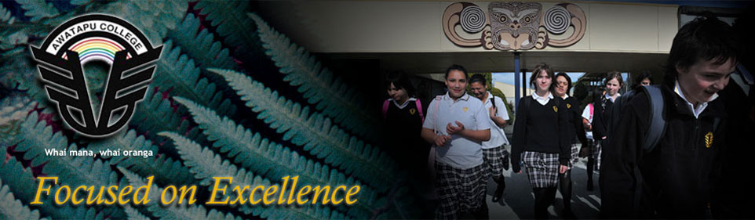
- Medium sized Palmerston North Co-educational College.
- Mid decile.
- About 20% Maori students with a strong focus on Special Needs.
- Range of Gateway, STAR, Work Experience and Trades Academy programmes both through U-Col and the College’s own Trades programme.
- Range of courses run under ITO accreditation
- Catering and Hospitality
- Construction/ House Building (BCITO)
- Tourism
- Retailing
- Engineering
- Motor Trades
- Electronics
- College based Trades Academy operates for selected students. This programme is based in the excellent technology complex which the College has developed over the years. This is a fine complex which is probably one of the best in the country and would rival many facilities found in Polytechnics. The equipment is extensive, modern and gives students opportunity to excel in all aspects as engineering, motor trades, electronics, construction and furniture. The College has accreditation from many ITOs which reflects the excellent staff skills and expertise.
- This Trades Academy allows students to work towards NCEA Levels1-3 and other qualifications on the NQF in the technology area.
- The College uses a Year 12 Level 2 mathematics course using ITO Unit Standards

    - North Shore Schools
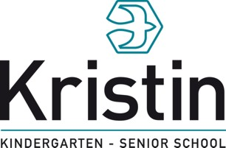
- North Shore, Auckland large Co-educational Private Year 1-13 School.
- High decile.
- No real vocational pathways.
- Students focus on NCEA Level 3, Scholarship and International Baccalaureate
- The only course being assessed against Unit Standards needing ITO accreditation is Outdoor Education.
- Extensive IT use in the learning process.
- All Middle School students have their own laptops and the seniors have a range of devices which are able to link into the school wireless network.
- With 550 students in the Senior School there are 800plus devices registered on the network.
- Devices such as Apple Macs, Laptops, netbooks, ipads and smart phones are used by students and staff in the learning process.
- IT devices and systems are extensive throughout the school.
- Each student must register their devices and individual code to access the network. Registration is cloud based using CLOUD CONNECT.
- School controls internet traffic through a central smart network system purchased from Palo Alto Networks.
- Numbers of school owned PCs are decreasing as students use their own devices.

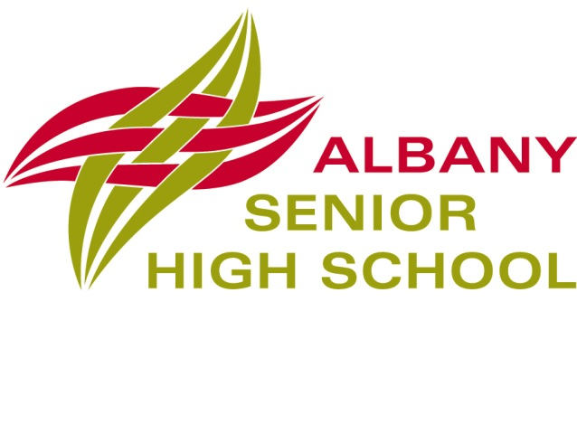
- North Shore, Auckland medium sized Co-educational Year 11-13 School.
- Newly established at Albany with scope to expand roll numbers.
- High decile.
- Modern multi-level school with modern facilities on a small site.
- Highly IT focussed.
- Learning commons with an open plan environment operate throughout the school.
- Timetable is based on each student taking 5 subjects. All courses have two 100 minute lessons per week. Students meet with tutors twice a week for career counselling, progress reviews and to keep tabs on general academic progress. It is also a time for students to complete any outstanding work.
 | Monday | Tuesday | Wednesday | Thursday | Friday
8.50-10.30 | 1 | Tutor Groups | Impact Project | Tutor Groups | 5
10.30-11.00 | Morning Break
11.00-12-40 | 2 | 4 | Impact Project | 1 | 3
12-40-1.30 | Lunch Break
1.30-3.10 | 3 | 5 | Impact Project | 2 | 4
- Most staff are tutors of groups of 10-15 students.
- There are no scheduled classes on Wednesdays but all students must take an Impact Project elective. These projects are student driven and involve staff and community members. Some may lead to NCEA credits.
- Gateway programmes operate on Wednesdays and the school has 100 places allocated.
- Range of courses run under ITO accreditation
- Creative Cooking (HIS)
- Travel and Tourism
- Automotive (Theory on-site and Practical off-site leading to national certificate in Motor Industry (Foundation Skills).
- Outdoor Education.
- Gateway and Star programmes operate in association with local polytechnics/Massey University and with local employers.
- IT is a key learning tool with over 500 devices registered on the wireless network.
- Control of the system is through Watchdog and Firewall.
- Most services are cloud based.
- KAMAR server is on-site but with a back in the clouds.
- Packages used include Google-aps, Moodle, and My Portfolio.
- Only one technician on site.
- Facebook, Twitter and U-tube are freely available.
- Facebook is commonly used for communication between school groups.
- Only two science labs in the school and these are only used for practical work. All other science lessons are held elsewhere in the learning commons.
- High IT presence and a variety of learning styles in operation.
- Learning commons are comprised of teachers from different curriculum areas.

  - South Auckland Schools

Papakura High School

- South Auckland medium sized Co-educational College.
- Low decile.
- Multi-cultural student base with high percentage of Maori, Pasifika and Asian students.
- Range of Gateway, STAR, Work Experience and Trades Academy programmes.
- Range of courses run under ITO accreditation.
- Land based Studies
- Catering and Hospitality
- Engineering
- Construction
- 120 Gateway places
- High focus on student pastoral care with school having two Maori Wardens, a nurse, one guidance counsellor, one youth worker, one social worker and a half time police in schools officer.
- The College is forging very strong links with local large industries. Input and advice from business personnel is helping to shape curriculum and programme design.
- Other key concepts being integrated into course planning involve important self-management elements such as punctuality, communication and no substance abuse.
- The College sees it as a major focus to move students into the workforce or further education especially as the community has high unemployment and is not a wealthy area.
- There has been an extensive review of senior curriculum structures and from 2013 all students will undertake programmes of study under the following Pathways.
- Service Hospitality
- Service Travel and Tourism
- Primary Industries Agriculture
- Primary Industries Construction and Infrastructure
- Community Creativity
- Community Health Sciences
- Traditional Six subjects leading to Level 3 NCEA
- Each Pathway has links with other providers including MIT, Auckland University, AUT, other Polytechnics and ITOs.
- Other links are already developed with Novotel Crowne (Hospitality), Hawkins and Stevensons (Engineering), ANZ (Travel and Tourism), Counties Manukau DHB (Health Sciences).
- Each pathway has a set structure with core components and some choices inbuilt.
- Personalised programmes will be part of the Pathways with off-site study and work experience built into the programmes.

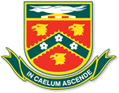Manurewa High School

Te Kura Tuarua o Manurewa
- South Auckland large Co-educational College of over 2000 students.
- Low decile.
- Multi-cultural student base with high percentage of Maori (25%), Pasifika (50%) and Asian students.
- Range of Gateway, STAR, Work Experience and Trades Academy programmes.
- Range of courses run under ITO accreditation.
- Catering and Hospitality (double option) with students also taking Business Studies, Maths and English.
- Engineering (from 2012 this is a full course with Maths and English included. No Maths/English on Fridays when students attend MIT all day.)
- Construction (double option)
- Outdoor Education
- Sports Leadership
- Early Childhood Education
- Business and Computing
- Many vocational courses involve students in study at MIT. These programmes usually off sit on a Friday and some subjects do not have a Friday lesson. However some do and there are difficulties at times with students missing some other subject lessons
- Many courses with the MIT option share the assessments with the College handling most of the theory component and MIT the practical elements.
- The College has very well appointed technical facilities and further restructuring and the purchase of new mobile major tools will allow more practical components of technology based courses to operate on site. The workshops have discrete machine rooms, general workshop space and central general rooms with computer access which services all technology students.
- Such mobile major equipment items included a Makita Table Saw, a Makita Drop Saw, a De Walt Planer, a Bosch Jig Saw and a Makita Skill saw (large model.)
- Some other qualifications which students can achieve through School/MIT partnerships include the following.
- National Certificate in Building, Construction and Allied Trades Skills Levels 2 and 3
- National Certificate in Mechanical Engineering Levels 2 and 3.
- National Certificate in Hospitality Levels 2 and 3
- National Certificate in Tourism Level 3
- National Certificate in Business Level 3
- MIT Certificate of Achievement in Early Childhood Education levels 2 and 3.
- The College did note some difficulties with accreditation processes with HIS. It noted that the ITO was overly demanding in its expectations of schools to assess against level 3 standards. No major issues were noted for Level 2 accreditation.
- Academic counselling is an integral element of the school and students and parents are involved with establishing and monitoring students’ educational plans and goals, ensuring that progress in monitored, course selection is wise and career directions are established and followed.

  - Waikato Schools

Cambridge High School
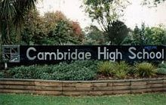

- Rural Waikato medium sized Co-educational School.
- High decile with about 13% Maori students.
- Maori achievement similar to all others and had improved over recent years. The school has good Maori retention to Year 11 and is aiming to increase retention after Year 11.
- Relationships are a key component of teaching and learning and the He Kakano project emphasises this aspect.
- Range of courses run under ITO accreditation.
- Catering and Hospitality
- Engineering
- Furniture
- Tourism
- Outdoor Education
- Sports Fitness
- Computing
- Electrical Engineering (with Wintec under Trades Academy umbrella)
- Mechanical Engineering (with Wintec under Trades Academy umbrella)
- Construction (with Wintec under Trades Academy umbrella)
- Wintec programmes operate as 3 six week full time block courses and lead to National Certificates at Level 2. Students in school programmes are adjusted accordingly in discussions between staff and students. Most students in the Trades Academy programmes take programmes which are built around Internal Standards.
- Students are transported to Wintec by mini bus which is funded through Wintec.
- 65 Gateway places with students moving from these courses into the workforce or polytechnics
- Some issues with students out of standard classes completing work missed when attending Gateway or STAR programmes.
- Some students have moved to Wintec after Year 12 under the Youth Guarantee umbrella.
- Some STAR courses are Stage 1 University courses for more able Year 13 students through Waikato or Massey Universities
- Mathematics at Level 2 in 2013 is going to be difficult with the expiry of the Level 2 Unit Standards. There is no suitable Level 2 course in Mathematics for those not at the level to take the Achievement Standards course. Some possibilities could be to build a programme around Unit Standards in Trades areas. Examples could come from Building, Engineering, Hair Dressing, Retailing etc. This issue is common in Waikato schools.
- SNUP upgrade just completed (September 2012) with UFB in 2013. Wireless network and BYOD from 2013. Student access only to Internet not school server.
- KAMAR in use for attendance, reports and NCEA. E-mail communication and website is used for communication.
- Goal setting with most staff having tutor groups is used to guide and focus students on learning and career pathways.

Hillcrest High School

- Large Hamilton Co-educational College of 1600 students.
- High decile.
- Range of Gateway, STAR and Trades Academy programmes particularly with Wintec.
- Range of courses run under ITO accreditation with some linked with Wintec.
- Automotive Studies,
- Childcare/Early Childhood Education,
- Construction/Furniture
- Retailing
- Engineering
- Catering and Hospitality
- Outdoor Education
- Electronics
- Motor Technology (with Fairfield Motors)
- Credits gained in these courses go towards NCEA but also towards other National Certificates which can be completed either by the end of Year 13 or at Polytechnic in later years.
- Gateway/Star and careers are managed jointly and operated from a centre which has classrooms and offices. It is managed by an experienced HOD with several support staff also involved.
- The centre also manages students involved in Vocational Pathways programmes who elect to follow any individual carer interests including those run through Wintec.
- The students use the facility to catch up on work missed when out on practical days although some issues do occur from time to time.
- The computer facilities also allow for students to personalise their programmes. The College purchases programmes under Star to allow this to happen
- Trades Academy is based at Wintec with students attending for one or two days depending on their courses of study
- IT is a key learning tool with a wireless network operational
- Control of the system is through Watchdog and the College Firewall.
- KAMAR server is on-site.

10. Bay of Plenty Schoolsog
in

TRIDENT HIGH SCHOOL

- Large Whakatane Co-educational College of 1200 students.
- Mid decile.
- Wide range of Gateway and STAR programmes.
- School managed Trades Academy with Trident as the lead school for Eastern Bay of Plenty High Schools. Most run in association with Waiariki Institute of Technology.
- In the Trades Academy programme students are aiming for National Certificates as well as NCEA. All courses aim to provide pathways to further higher level qualifications in the vocational area either through Waiariki Institute of Technology or through other Tertiary providers.
- Courses are 2 year programmes. In Year 1 students attend Waiariki Institute of Technology for one day per week (each Thursday) and Year 2 students attend on both a Thursday and Friday.
- National Certificates available to students in the programme from all schools in the consortium include the following.
- National Certificate in Agriculture and Farm Maintenance Level 3
- Certificate in Entry to Automotive Trades Level 2
- Certificate in Office Skills Level 2
- Certificate in Business Administration Level 3
- Certificate in construction Skills (Introductory) Level 2
- Certificate in Electrical and Related Trades (Pre-Employment) Level 2
- Certificate in Forestry Fundamentals Level 3
- Certificate in Hairdressing Level 3
- National Certificate in Health, Disability and Aged Support (Foundation Skills) Level 2
- National Certificate in Health, Disability and Aged Support (Core Competencies) Level 3
- Certificate in Cookery and Hospitality (Introductory) Level 3
- The Trades Academy information booklet gives a full breakdown of the programme components, aims and future qualifications along with possible career opportunities which may unfold.
- About 210 students attend the Trades Academy with about 40 from Trident High School with the balance coming from the other Eastern Bay of Plenty secondary schools.
- Students are very keen to attend the Trades academy and while they may find being back at school less exciting it has given them an increased focus and achievement has improved.
- All Year 12 students take 6 subjects plus Trades Academy, although they may not take all standards offered in the course. Some consideration is being given to changing this to 5 subjects in 2013.
- Year 13 students in the programme take 5 subjects.
- School courses aim to support the Trades Academy programmes even though the majority of students in school based courses are not at the Trades Academy. There have been some alignment issues between school and Trades Academy programmes. These have been managed by teachers and tutors working together. Further alignment will occur for 2013.
- Each student attending the Trades Academy has their academic programme personalised and adjustments made where necessary.
- After Year 12 some students stay in the programme, some return to a full time NCEA programme at school and some go to full time Polytechnic (either under Youth Guarantee or as a fee payer).
- Credits gained through the Polytechnic are sent directly to NZQA.
- Trident if the Trades Academy fund-holder and the Principal is the Chair of the governance group.
- A management group also exists for operation oversight and direction.
- The Trades Academy is not for low achievers. Students need to have at least 60 Level 1 credits including literacy and numeracy and preferably Level 1 NCEA to enter the programme .Some flexibility exists to take students mid-year.
- Class sizes are about 15-18 in the programme. The programmes tend to have more boys but more girls are now taking courses such as Business Administration, Hairdressing and Health.
- Work experience in the programme is on Polytechnic days only and often as part of contracts which the Polytechnic has organised. This allows Gateway students to have their work experience on each Thursday with employers who are able to take them. The two groups do not flood the places available.
- Trident has 55 Gateway places. Students take a Gateway course, which involves work placement in lieu of one subject line.
- At Trident Thursday has four shortened lessons plus electives (sports practices etc.). This means that students out at Polytechnic or work placements have less disruption to their school programmes.

Tauranga Boys College

- Large Tauranga single sex College of 1600 students
- High decile
- Range of Gateway, STAR and work experience programmes. School based Academy for about 15-20 boys.
- All Pathways programmes managed through Rob Sperling, Academy Director.
- Range of courses run under ITO accreditation
- Land based Skills
- Tourism
- Construction and wood related trades
- Engineering and Auto Trades
- Catering and Hospitality
- Outdoor Education
- Electrotechnology
- Gateway programme operates in Years 12 and 13. Students apply for entry.
- Work programmes arranged by students and can occur at any time including holidays, weekends, after school etc.
- If students wish to take school time they need to get teachers to identify assessments etc. and to support their time out. In any dispute the parent has the final say.
- No specific Gateway line on the timetable.
- Students work in 5 days blocks and only get a further block if the last one has been successful.
- During each Gateway block a course booklet needs to be fully completed and the programme must have met all criteria for the student to undertake a further programme.
- Many work place opportunities available in the community often through long term connections.
- Some consideration being given to students undertaking a work experience block, involving many trades to be based in Christchurch.
- The Academy is a specific programme which has been operation for some years. It operates for a range of boys who have found mainstream programmes difficult.
- It has Academic Counselling at the centre of the programme and relationships remain the key focus of the programme
- Many successful professional, business sporting and trades people have come out of the programme
- The programme aims at level 3 NCEA.
- There is a vocational focus and programmes are purchased under the STAR umbrella.
- Students undertake 2 days of work per week and can gain credits from these placements.
- At the end of the course he aim is for each student to know
- Who am I?
- Where am I going?
- How do I get there?
- Some students return for Year 14 to get Level 3
- Programme involves Day Skippers course, Health and Safety, First Aid and a variety of other purchased programmes.
- English standards are organised in house on an individual basis.
- The programme revolves around Rob Sperling and his charismatic manner means that the boys in the Academy are given a real opportunity to be successful

- South Australia
In October 2011 I attended the ACEL Conference in Adelaide. This Conference had several sessions relating to the senior secondary school and how programmes operate to transition students from school to the workforce or into further training.
A summary of how this system operates in the Riverlands area follows.

RIVERLAND TRADE SCHOOL

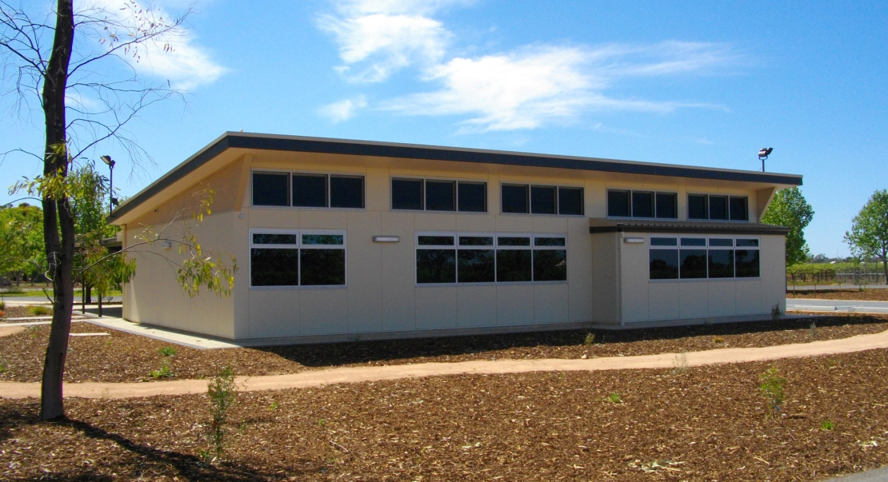

What is the Trade Schools for the Future?

The Trade Schools for the Future program is an education initiative that enables government high school students to combine their South Australian Certificate of Education (SACE) studies with Vocational and Education Training (VET) in the form of a school-based apprenticeship or traineeship. The Trade Schools for the Future program aims to ensure students have genuine career pathways and that employers gain motivated, trained and work-ready employees. Regions within South Australia have a Lead School, specialist Apprenticeship Brokers and an Assistant Principal who support schools and students within their region, to advise and link students and employers into School-based apprenticeships and traineeships while also contributing to or completing their SACE.

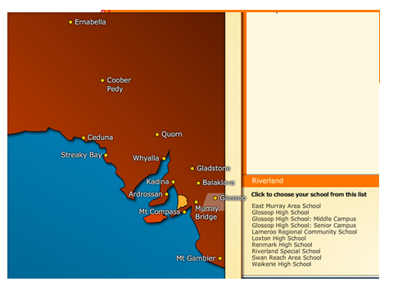





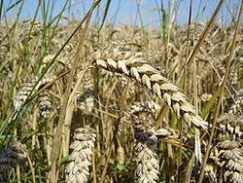


Irrigation industries, horticulture, wine production, river related tourism, dry land farming and grazing and other industries that support the individuals and families within these key areas

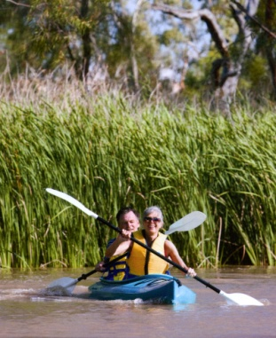
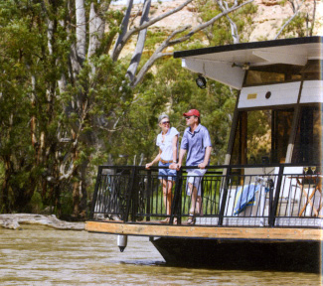



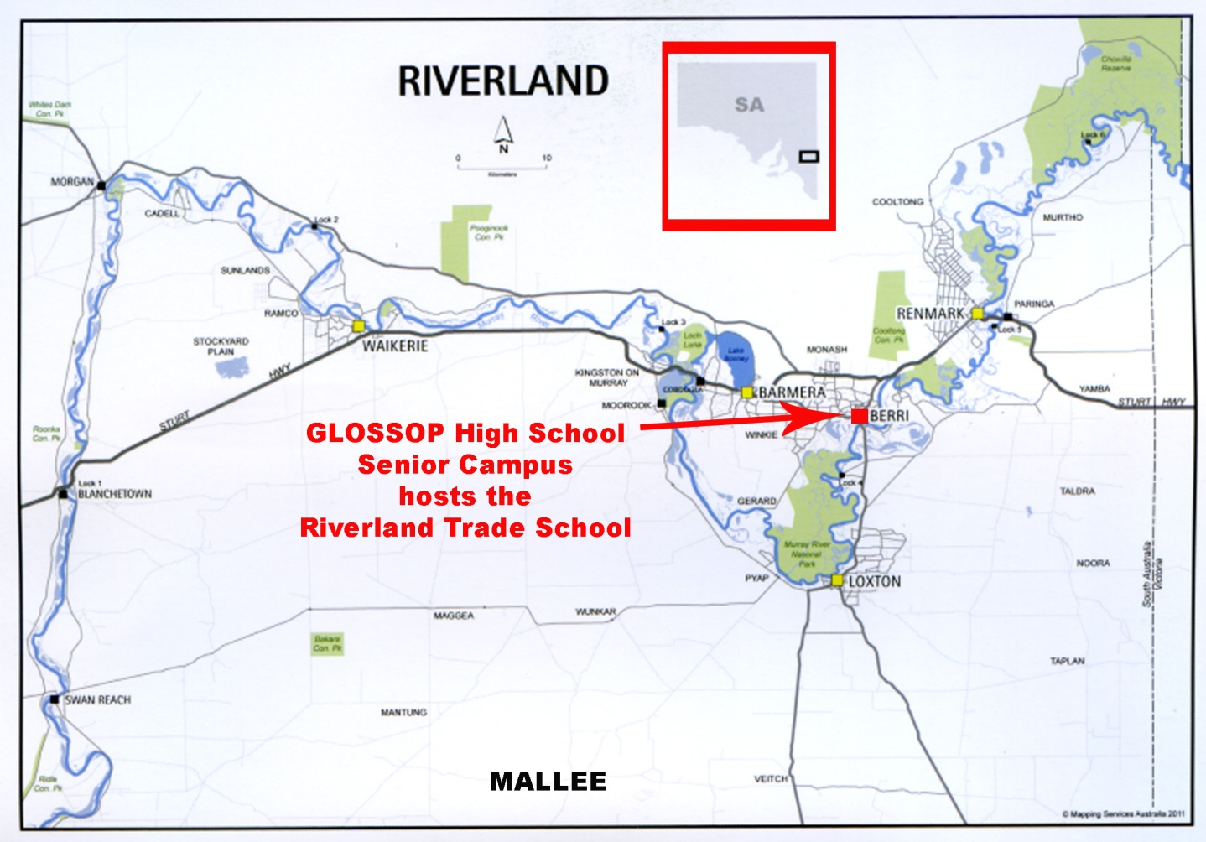

How they work

TRAINEESHIPS:
A Traineeship allows senior high school students to combine paid work with school.
Students undertake Certificate 2 or 3 training associated with their employment and earn SACE credits towards both stage 1 and 2 of their schooling depending on their qualification.
APPRENTICESHIPS:
A student can begin the first year of their trade apprenticeship whilst they are still attending school. With negotiation between the school and the employer students can work 1 or more days per week in the workplace along with starting their RTO training.
Students undertake a Certificate 3 level trade qualification. .

What are the benefits for students

- Earning money while going to school.
● Gaining a nationally recognised qualification whilst at school.
● Earning credits towards SACE.
● A real sense of achievement.
- A great start to a career whilst at school.
- Work & training completed whilst at school is credited. (shortens apprenticeship time requirement)
- Hands on experience in a real job.

What are the benefits for employers.
- Attractive commonwealth incentives.
- Work cover, payroll tax rebates.
- Flexible working conditions.
- Choice of best potential employees before young people hit the workforce.

What are the benefits for Schools.
- Ability to claim full time equivalent for Trades School students
- SACE credits from training to help students achieve their SACE.
- Flexible options to help schools work around timetabling.

How long does a Traineeship or Apprenticeship take to complete?

TRAINEESHIP:
Commencing in year 10 or 11 (Year 11-12 in New Zealand) students should complete by the end of Year 12.
If is not completed, the student can convert to either a part time or full time Traineeship until it is completed.
Traineeships are competency based - if bookwork is finished and the employer thinks the trainee is competent in all areas they can be signed off.
APPRENTICESHIP:
Students commencing an Apprenticeship will work part time whilst at school.
Students will continue as a full time apprentice when their schooling is complete.

How much time is spent away from school?

School-Based Traineeships and Apprenticeships can be completed in a number of ways. It could be by working one or more days a week including:
casual work after school, on weekends, during school holidays or it may include a block release of time to work with the employer.
An average of at least eight hours a week on the job employment is required.

The SACE and ASBA’s
The ASBA’s training can be included in the students’ SACE pattern. Every 70 nominal hours of study is equivalent to a 10 credit SACE Board Subject (1 semester). The students’ subject load can be modified according to the amount of training being completed each year.
ASBA’s are generally Cert. 3 training so they can get SACE credits for both Stage 1 and Stage 2. The training could make up 150 of the200 credits required to achieve their SACE.

SACE Pattern
An example of a pre University ATAR student involved in a Traineeship programme who completed CERT.3 in Childcare
Stage 1 – Year 11(12 NZ)

Stage 1
Literacy
20 credits
Stage 1
Numeracy
10 credits
Any
10 credits
Any
10 credits
Any
10 credits
Any
10 credits
Any
10 credits
Any
10 credits
Any
10 credits

Stage 2 Year – 12 (13 NZ)
Stage 2
20 credits
Stage 2
20 credits
Stage 2
20 credits
Stage 2
20 credits
Stage 2
20 credits

Completed
Cert.3
childcare
3 x 20 credit stage 2 subjects

Other possibilities could be:
- Cert. 3 aged care, Cert. 3 Business and Cert. 3 hospitality/commercial cookery
- A completed cert.3 can be counted as a 20 credit stage 2 subject and is given a score averaged against your other 60 credits of stage 2 . Workplace Practices could be one other 20 credit stage 2 subject

Career options have included:
Traineeships
Retail
Pharmacy Assistant
Business
Agriculture
Tyre Fitting
Warehousing
I.T.
Childcare
Agriculture/Horticulture

Apprenticeships
Diesel Mechanic
Agricultural Diesel
Automotive Mechanic
Electrician
Hairdressing
Irrigation
Plumbing
Panel Beating / Spray Painting
Engineering

- Summary Observations – Pathways

There are some common themes identified during the visits to schools.

Many ITO accredited programmes are common in schools.
- Catering and Hospitality
- Engineering
- Furniture
- Tourism
- Outdoor Education
- Sports Management
- Computing
- Construction/Furniture
Schools in rural areas have developed other links to offer courses suited to potential career paths for their students
Gateway is effectively used in all state schools.
STAR is used to widen opportunities for students. The use varies with some schools buying programmes, paying for programmes at local Polytechnics or running small groups under their own accreditation.
The Trades Academies are offering new and exciting pathways for students. There are a number of models throughout the country and each has evolved to suit the needs of the communities they serve.
The Eastern Bay of Plenty model is probably the most advanced in that there are clear pathways for students to gain qualifications other than NCEA but still attached and part of their home school.
The WelTec model has its place but being full time the students can lose contact with their school. Also other students who would benefit from a periodic or regular one day programme are not getting this opportunity unless the school purchases the course for them. A mixture of both types of course would be worth considering.
Other schools tend to offer courses which lead in part to other qualifications but most still focus on NCEA except where Trades Academies are involved. This initiative has given a wider set of opportunities for students, has encouraged then to stay at school and has given wider career options.
More schools are integrating the location of careers/Gateway/STAR and other career focussed activities in a common complex with key co-ordinators managing these areas. This is dependent on facilities being available but it appears to be successful
Many schools are adapting their timetables. There are variations to structures as schools endeavour to deliver successful programmes to all students in a changing, technologically changing 21st century environment. Increasingly schools are running a 5 period day with 2 periods before a break, two periods then before lunch and one period after lunch. Breaks are of similar length. Some schools are operating the middle two lessons as a double period which gives additional bonuses for practical work and trips.
Some schools are operating three 90-100 minute lessons as a variation with others having two week cycles or different number of lessons on each day to offer a varied curriculum
Lower decile schools are more advanced with Pathways programmes. This is probably because of longer involvement with such programmes and the greater need to find alternative courses for senior students which can lead to career opportunities.
Many higher decile schools are now adjusting their course structures to widen opportunities for students. Much depends on staffing availability, closeness to Polytechnics and potential career opportunities in the local area.
Travel can be an issue in allowing students to access outside school opportunities.
Most successful programmes are reliant on key personnel who have a dedicated approach to their students and to the new Pathways which are evolving
Links with the wider community are getting wider and greater. The involvement and blurring of the secondary/Tertiary interface is making transitions for students much easier. Equally involvement with other providers/employers is giving schools and employers opportunities to give more students workplace experiences.
Technology and its use is becoming more common and greater use of digital devices should be encouraged. Students see technology, especially digital technology, as a normal and integral component of their lifestyles. Using digital technologies is how they work.
The South Australian Trades School approach offers opportunity for students to move into the workforce or further Trades Training and also allows for students to have flexibility when they do their work experience. Time at work counts for credits in the SACE (equivalent to NCEA). Students may also be paid while attending the programme. Many traineeships and Apprenticeships have also be gained through this scheme.
The operation of Trades School brokers is a good idea as it allows for the one person to liaise with both schools and employers. Funding for schools is maintained even if students are attending off school programmes.
On a specific matter the removal of Unit Standards at Level 2 in Mathematics is causing issues in most schools. Many students involved in Pathways programmes want a basic Level 2 numeracy programme but would struggle with Level 2 Mathematics Achievement Standards. Schools are struggling to find a suitable set of standards which could be used to give students an appropriate and satisfactory mathematics programme

- Thoughts and suggestions

Consideration should be given to further enlarging the number of Trades Academies in the country

Schools should be encouraged to set up their own consortia to operate Trades Academies and to focus on widening qualifications which students can achieve at school other than just NCEA.

There are many successful Pathways programmes operating in schools. The MOE should be encouraged to further facilitate the promotion of these successful Pathways programmes whereby schools which have shown leadership in the area being asked to share their experiences with other school which could benefit from being exposed to others’ experiences. Current programmes are very good and should be widened.

There does need to be some thought as to how students who undertake out of school activities as part of their programme can avoid being disadvantaged in their other school based subjects. This is probably a matter for each school to examine and some flexibility on all sides is necessary.

A suggested timetable to have some flexibility for senior programme delivery could be as follows. Schools would need to look at how the juniors fit the structure. Seniors taking time out for gateway/Star/Trades Academy would have no other subjects allocated in Lines 5 and 6 and this would lessen the impact of time out of school

 | Monday | Tuesday | Wednesday | Thursday | Friday
8.45-9.05 | Form Period/Tutor Time/Assembly
9.05-10-05 | 2 | 6 | 3 | 1 | 4
10.05-11.05 | 3 | 5 | 3 | 6 | 5
11.05-11.35 | Morning Break
11.35-12.35 | 1 | 2 | 4 | 5 | 6
12.35-1.35 | 1 | 2 | 4 | 5 | 6
1.35-2.15 | Lunch Break
2.15-3.15 | 4 | 3 | Years 9-11 classes | 2 | 1

Learning/Pathways centres in schools with appropriate personnel involved could allow for his flexibility and to keep students heading in the right direction.

Academic counselling is critical to students’ progress no matter what direction they are taking. The concept of small tutor groups is becoming more common and this should be promoted as a good idea.

As with all area funding is an issue. The question of funding mechanisms for Level 1 and 2 courses is under review and this need some urgency so that future directions can be clear.

There are a wide range of programmes which have evolved over the years which relate to the senior secondary school/Tertiary /workplace interfaces. Such programmes as STAR, Gateway, Trades Academies, Youth Guarantee fees free places are primary examples. Each has its own funding and reporting mechanism but, in the end, is focused on similar outcomes.

Digital technology and BYOD opportunities should be encouraged and schools would benefit from seeing how other schools use this approach. Digital technology is part of students’ lives and it must be part of the learning process. PCs will probably diminish, and other devices will expand in use and access. Schools will need to ensure their IT systems are capable of delivering the necessary access and equitable access is needed for students from poorer backgrounds. This is a major challenge.

The integral use of digital technologies raises the issue of how, when and where students are involved in their formal learning programmes. It is no longer essential that students attend school for a specified period of time as learning is much more flexible. Hence there should be more flexibility for students and schools to operate outside of the traditional structures. This would need some changes to legislation, funding and resources structures and attendance requirements. These issues warrant further consideration if schools are to deliver a 21st century education for 21st century students.

There needs to be an awareness to avoid what is implied in the following quotes:-

- “here we are the generation of tomorrow being taught by the generation of today using the techniques of the generation of yesterday”
- “education is what is left when you have forgotten what you learnt at school”
- “if you do business today like you did yesterday then you will not be in business tomorrow”

The recently published discussion documents on Pathways from the MOE are an important component in moving senior education towards a more flexible future. The integration of the ideas being presented in these documents plus greater flexibilities for schools, wider use of digital technology, career/individual counselling, personalised programmes and planning for a globalised world should allow for students to move successfully from school into the workforce or further education and training.

Technological change, increasing globalism and a move into the Conceptual Age is demanding change at all levels of education. The blurring of the secondary-Tertiary interface is but one of the changes occurring in the modern 21st century environment.

Acknowledgements

Thanks are due to the personnel I was fortunate to speak with during Term 3 2012. The experience has given me a wider insight into the Pathways area but the opportunity to sit and talk with colleagues was equally beneficial

Specifically I would like to thank the following for their time and willingness to share their experience, thoughts and knowledge

- Arthur Graves National Manager, Youth Guarantee Networks, MOE,
- Josh Williams Vocational Pathways Manager, Youth Guarantee Networks MOE
- Alan Peck Executive Dean Faculty of Trades and Technology WelTec
- Trish Collett Manager Trades Academy WelTec
- Fiona Wain School Liaison Officer Youth Guarantee Whitireia Polytechnic
- John Russell Principal Naenae College
- Murray Lucas Principal Tawa College
- Peter Leggat Principal Onslow College
- Mike Webster Principal Mana College
- Tina Simms Principal Awatapu College
- Mike Schwass Principal Wairarapa College
- Tom Hullena Principal Makoura College
- Geoff Shepherd Principal Kurunui College
- Barbara Cavanagh Principal Albany Senior High School
- Mark Osborne Deputy Principal Albany Senior High School
- Brendan Kelly Senior School Principal Kristi School
- Salvi Gargiulo Principal Manurewa High School
- Peter Heron Principal Papakura High School
- Phil McCreery Principal Cambridge High School
- Kelvin Whiting Principal Hillcrest High School
- Scott Barry Director Vocational Pathways Hillcrest High School
- Peter Tootell Principal Trident High School
- Robert Mangan Principal Tauranga Boys High School
- Rob Sperling Director Academy Tauranga Boys High School

Richard Campbell
Principal
Paraparaumu College
September2012

